Sample communication for CCC AI Systems Training License holders
The following is provided to assist you in introducing the AI Systems Training License and RightFind® Advisor to employees. You can use this text in an email message, posting on your company intranet, or in your company newsletter.
Subject: Responsible AI development just got easier with the AI Systems Training License
Did you know that permission is typically needed from the copyright holder for certain uses of materials for the training of AI systems?
Now training AI systems in a copyright-compliant way is easier than ever at [Company name].
We’re excited to introduce the AI Systems Training License from CCC, a single-source licensing solution that supports our organization’s AI systems training initiatives. By choosing the AI Systems Training License, [COMPANY NAME] has shown commitment to supporting responsible AI development through the compliant use of copyrighted materials.
How can the AI Systems Training License help you?
The AI Systems Training License is a voluntary, non-exclusive solution for organizations training AI systems for use by users internal or external to their organization. It provides the rights to lawfully use a wide and diverse repertoire of content for training AI systems.
Adopting the AI Systems Training License will help support our development of AI-powered applications. This license helps us:
- Support our compliance strategy by utilizing a cost-efficient license that includes rights to use content from a variety of sources.
- Align with market demand for licenses that permit the training of ethical, high-performing systems with content from a wide range of providers, enabling responsible AI.
- Leverage rights to high-quality content from trusted sources to strengthen the integrity of inferences.
What does this license not cover?
This is a rights-only license and does not provide access to or authorize scraping of content. Content must be legally acquired before works can be used under the license. This license does not cover:
- Uses that would substitute for primary content access.
- Uses other than training (e.g., RAG models, the use of works as prompts or inputs other than for training purposes).
- Outputs that are substantially similar to a covered work used as an input; reproduction of all or any substantially intact portions of any work; or are "in the style of" an author.
- Use of AI by end users beyond accessing and prompting the trained AI.

How can you check what’s covered with the Annual Copyright License?
The AI Systems Training License comes with RightFind® Advisor, a quick, reliable way to verify rights included in the license. Click here to log in or visit our intranet to access RightFind Advisor and then enter the Publication Title or Standard Number (ISBN/ISSN) in the search box.
License coverage, shown in the screenshot below, is listed under “How can I use this copyrighted content?”
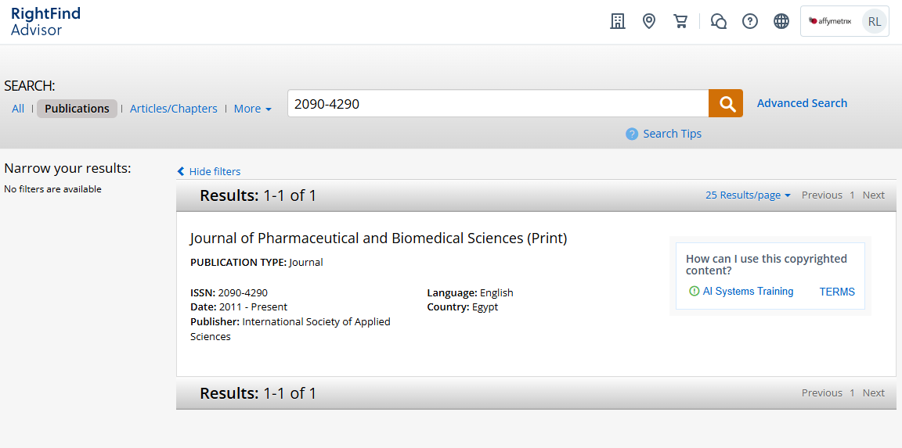
For more information about our AI Systems Training License or RightFind Advisor, please contact [Company contact] at [email or extension].

