**Sample communication for CCC Annual Copyright License holders**

*Use the sample text below to introduce the Annual Copyright License and RightFind™ Advisor to your employees.*

Companies such as ours depend on the exchange of information from research and industry news to workforce trends and legislation. This information can come from a number of sources, most of which can be found online. If you use and share print and digital content without permission of the copyright holder, you and [Company name] face the risk of copyright infringement.

To alleviate that risk, we’ve acquired an Annual Copyright License from Copyright Clearance Center (CCC) that gives [Company name’s] U.S.-based employees the rights to share content from millions of information sources across our organization, including journal articles, news, blog posts and more.

With the license you can:

* E-mail online articles to fellow employees and coworkers
* Distribute copies of published articles at internal meetings
* Post excerpts of industry research on corporate intranet sites
* Print and copy published articles to share with colleagues
* Download content for use at company meetings

The license also authorizes external distribution of materials in the following two situations:

* Sharing a single electronic copy of an article with a client, customer, or prospect upon a specific request
* Submitting properly marked copies of articles to government agencies for regulatory filings

Note, however, that the license does not cover the external display of copies on mobile devices as part of the user’s systematic sales or marketing activities.

The license also comes with RightFind™ Advisor, a tool which enables you to quickly confirm license coverage for specific publications. Just [click here](https://www.rightfind.copyright.com) to access RightFind and enter the Publication Title or Standard Number (ISBN/ISSN) in the search box. License coverage is shown below the search results under “*How can I use this copyright content?*” See screenshot below.

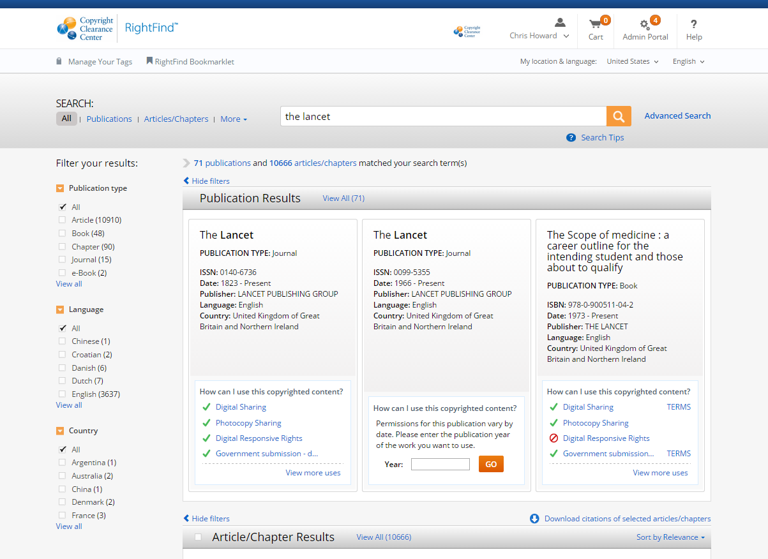

For more information about our Annual Copyright License or RightFind, please contact [Company contact] at [email or extension].